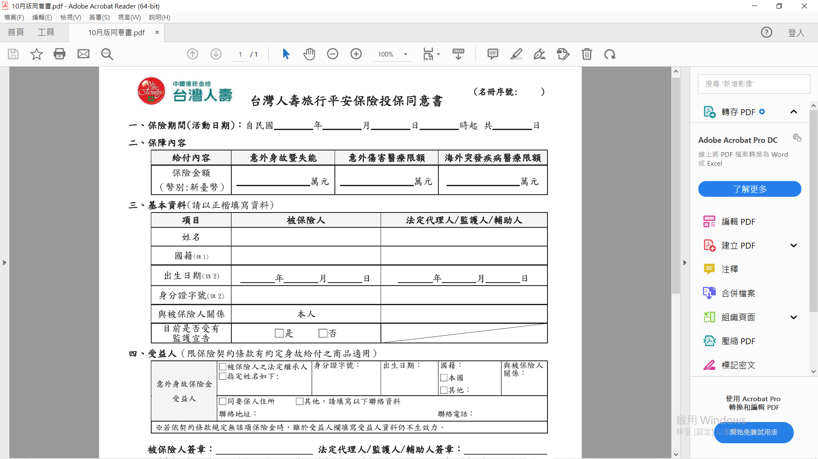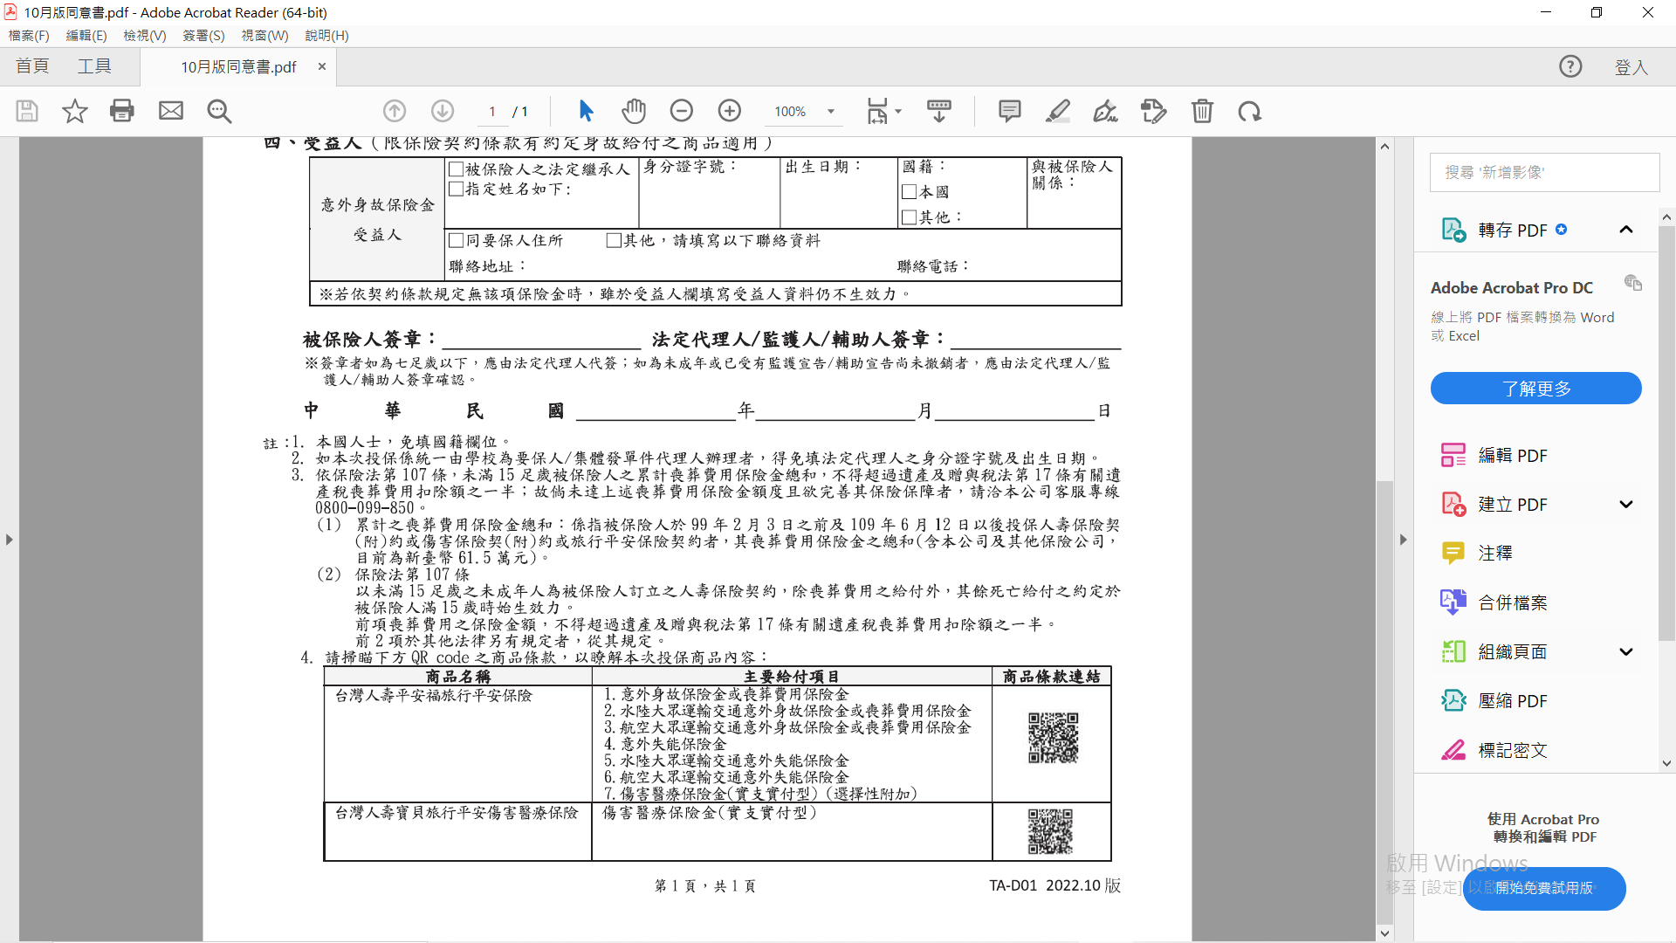

111

🗸

🗸

🗸

🗸

🗸

🗸

🗸

🗸

🗸

🗸

🗸

61 .5 5

112 03 04 0 1